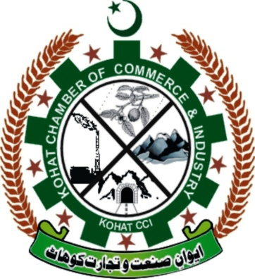

**Kohat Chamber of Commerce &**

**Industry**

**Minutes of Meeting Executive Body (13-07-2022)**

**Subject: Approval of “Election Commission/ Voter List and Election Schedule”.**

The executive body meeting was held at Kohat Chamber of Commerce and Industry office at Kotal Shopping Arcade old Jail Road Kohat on Wednesday 13th July 2021, at 11:00 0’Clock for discussion and finalizing approval of Election Commission, Voter list and Schedule of Election. Meeting was chaired by the Mr. Malik M.Asad Khan a president of KTCCI.

The meeting was properly started with the recitation of Holy Quran. All the members of executive body participated in the meeting. Mr. Wajid Khan, Secretary General, briefly inform executive body about the Schedule of Election, Voter List and Election Commission and he got approval. He also explained the executive body about the role of Election Commission for the prosperity of Kohat Chamber of Commerce & Industry.

The Secretary general further added that at this very current stage of KTCCI we should focus on increasing membership rather than focusing external matters of the chamber. All the executive members strongly agreed to elect **Mr.Saqib Mehmood, Mr. Abdul Qadus and Mr.Abid Hussain** for the Election Commission of Kohat Chamber of Commerce and industry.

The president of KTCCI Mr.Malik Asad Khan told the forum that with Blessings of Almighty Allah, the KTCCI is growing day by day and the importance and need of Chamber for business community in Kohat is recognized strongly. The two newly districts of FR Kohat are merged in Kohat Division and KTCCI will play a vital role in development and growth of business in that areas.

**Secretary General**

**Wajid Khan**

**Name & Signatures of the participants are:**

The Meeting ended with thanks from/to the chair.

**S# Member Name Signature**

1. Mr. ______________________________
2. Mr. ______________________________
3. Mr. ______________________________
4. Mr. ______________________________
5. Mr. ______________________________
6. Mr. ______________________________
7. Mr. ______________________________
8. Mr. ______________________________
9. Mr. ______________________________
10. Mr. ______________________________
11. Mr. ______________________________
12. Mr. ______________________________

**Secretary General**

**Wajid Khan**